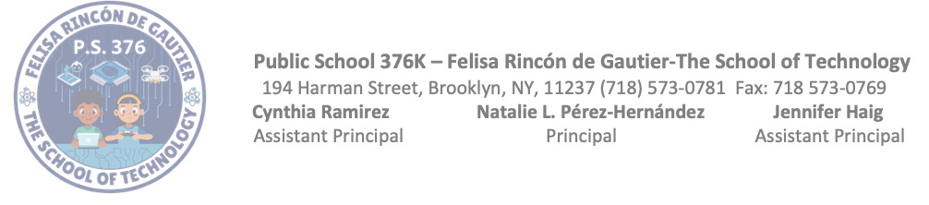

December Meeting Minutes

6:00 pm – Welcome
6:05 pm – Introduction of board members
6:10 pm – PSA president’s report
- NYCSA account creation, Parent Coordinator sent out account creation codes, If you need any assistance feel free to come in to the school and myself (Ms. Rodriguez) or Ms. Valdez (Parent Coordinator) will assist in the account creation.
- Multicultural event/ potluck was a success and so was fall festival.
6:15 pm – Secretary’s Report
- Daisy Delgado gave September minutes, and they were approved.
6:25 pm – President spoke about October & November minutes & minutes were approved.
6:35 pm – Treasurer’s Report
- $2,912.54 minus $16 bank fee.
6:40 pm – Principal’s Report
- Reported state of our school.
6:50 pm – No new business, Floor opened for Q&A/ comments or concerns.
7:00 pm – Meeting adjourned.

